Trinity Church
December 22nd, 2019 – Fourth Sunday in Advent
Family Worship 10:30 a.m.

Church Life Charles Hinerman

Prelude Mengfei Xu

Lighting of the Advent Candle Steve & Mimi Joyce

Childrens Program

*Opening Praise & Worship pg. 145; vs. 1-3
“O Come All Ye Faithful”

Connections pg. 151; vs. 1,2
“Good Christian Men, Rojoice”

Morning Prayer Marc Putnam

Welcome Francis Williams
If you are seated on or near an aisle, please take out the
red attendance register, sign it, and pass it on.

Children’s Message Kiki Samba

Offertory Trinity Men’s Choir
“Do You Hear What I Hear?”
Arr. Harry Simeone
*Doxology

Anthem “Westminster Carol”
By Carl Nygard

Scripture Lesson Matthew 1:18-25

Sermon “Mystery” Marc Putnam

*Closing Worship pg. 133; vs. 1&3
“Hark the Herald Angels Sing”
*Benediction

*Postlude Mengfei Xu

*Congregation to Stand

Welcome to Trinity Church!

Greeters today Steve & Mimi Joyce,
Nancy Bell & Carole Gibson

Announcements:
Tasteful or tacky, who doesn't like Christmas lights. Join the Trinity family as we take a bus tour of Greensboro neighborhoods to celebrate the lights. We may even stop for some hot chocolate along the way. The bus will leave the church at 5:30 Sunday evening, December 22.

Trinity members have the opportunity of going on a mission trip to Alaska Christian College in Soldotna, Alaska June 16-13, 2020. If you are interested, please let Pastor Marc know today.

Bring your Christmas cards for Trinity members and put in the large Trinity Mailbox in the atrium! They will be sorted and “delivered” to a pick up box where you can find cards addressed to you in alphabetical order by last name. Plan to mail your cards here and also remember to stop by the box each week to receive cards addressed to you! Donations are appreciated for this service, and will be given to the International Students towards their monthly dinner.

The William Mangum Honor Cards are available at Trinity Church for $5 each. 100% of your $5 donation goes directly to help the homeless and hungry at Greensboro Urban Ministry. Please reach out Lynn Wood if you would like to help.

In this season of remembering the blessings God, we want to remember those around the world who have so little to eat. We ask each family to pick up an Advent Box this Sunday in the Atrium and fill it with change during the holiday season, then return it after Christmas. This money will be used to kick off our Feed the Hunger Pack-a-Thon.

The Golden Heirs covered dish lunch with Owen & Judy Allen has will be rescheduled for a later date. More to come!

Join us for coffee, rolls, song and candle lighting when we gather for our Love Feast in the Moravian tradition on Christmas Eve, Tuesday, December 24th from 5:30-6:30 pm. Five couples are needed to serve the Love Feast on Christmas Eve. Please consider helping with this holy service. Contact Madeline
Bradley at 336.286.8676 or via email at madeline@bradleydata.com if you
are willing to serve.

Save the Date! Prayers & Soup for The New Year. Join us on Tuesday, December 31st at 12 p.m / noon. This is a special time to stop and thank God for all His blessings of the past year and commit the coming year into His hands. Sign up sheets are out in Nathex and Atrium. Please sign up or call the church office.

Financial Update: Our 4th quarter operating fund giving goal is $150,000. $127,557 has been given as of 12-20-19 to meet the goal leaving a challenge of $22,443 for the remainder of December. Please pray that God will supply our need, join us in worship, and give as God blesses you.

Congregational Meeting: There will be a Congregational Meeting on Sunday morning January 12 at 9:30 AM to vote on passage of proposed Bylaws. Trinity’s Bylaws were rewritten last year to streamline the function of our elder board and ministry teams. The proposed bylaws also were written to improve clarity in procedure. There are no substantive changes proposed to congregational life or doctrine. The proposed Bylaws and an Addendum explaining the church’s foundational theological positions are available on the Trinity Church website or in hard copy through the church office. Our Articles of Incorporation require a 2/3 majority vote of active membership for acceptance of the proposed By Laws. We will need at least 95 persons to attend and vote for the measure. Please inform yourself of the proposal and be present Sunday morning January 12 at 9:30.

Lectionary Reading:

December 22nd – Isaiah 7:10-16; Psalm 80:1-7,17-199;
Romans 1:1-7; Matthew 3:1-12

December 29th – Isaiah 63:7-9; Psalm 147:12-20;
Hebrews 2:10-18; Matthew 2:13-23

Nursery and Kidzone:

December 22nd
Nursery – Matt & Amy Brown
Kidzone – Lynn Moudy, Ella McClellan and Roland Ken Williams

December 29th
Nursery – Elizabeth McClellan & Elaine Putnam
Kidzone – Kiki Samba and Victoria Lakhavani

If you are visiting with us today, please pick up a Visitors Packet
at the back of the sanctuary. Thank you for being a part of our service!
We welcome you to join us again.

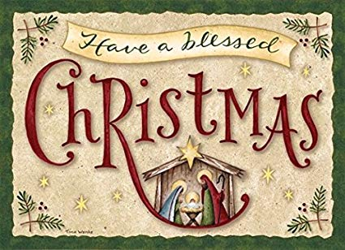

Sunday, December 22nd
8:30 a.m. Early Worship in Sanctuary
9:30 a.m. Preschool & Elementary Children
9:30 a.m. Bible Reading Class
9:30 a.m. Sonshine/Fellowship Class
9:30 a.m. Good Medicine Class
9:30 a.m. Family Focus Class
10:30 a.m. Family Worship in Sanctuary
1:00 p.m. Slavic Church
5:00 p.m. Pioneer Clubs

Tuesday, December 24th
5:30 p.m. Christmas Eve Love Feast

Wednesday, December 25th
Church Office Closed
All regularly scheduled activites are cancelled
for the Christmas Holiday. Merry Christmas!

Thursday, December 26th
Church Office Closed

Sunday, December 29th
8:30 a.m. Early Worship in Sanctuary
9:30 a.m. Preschool & Elementary Children
9:30 a.m. Bible Reading Class
9:30 a.m. Sonshine/Fellowship Class
9:30 a.m. Good Medicine Class
9:30 a.m. Family Focus Class
10:30 a.m. Family Worship in Sanctuary
1:00 p.m. Slavic Church
5:00 p.m. Pioneer Clubs

Trinity Wifi Password: Godlovesyou
Website: TrinityChurchgso.org
Facebook: Trinity Evangelical Covenant Church

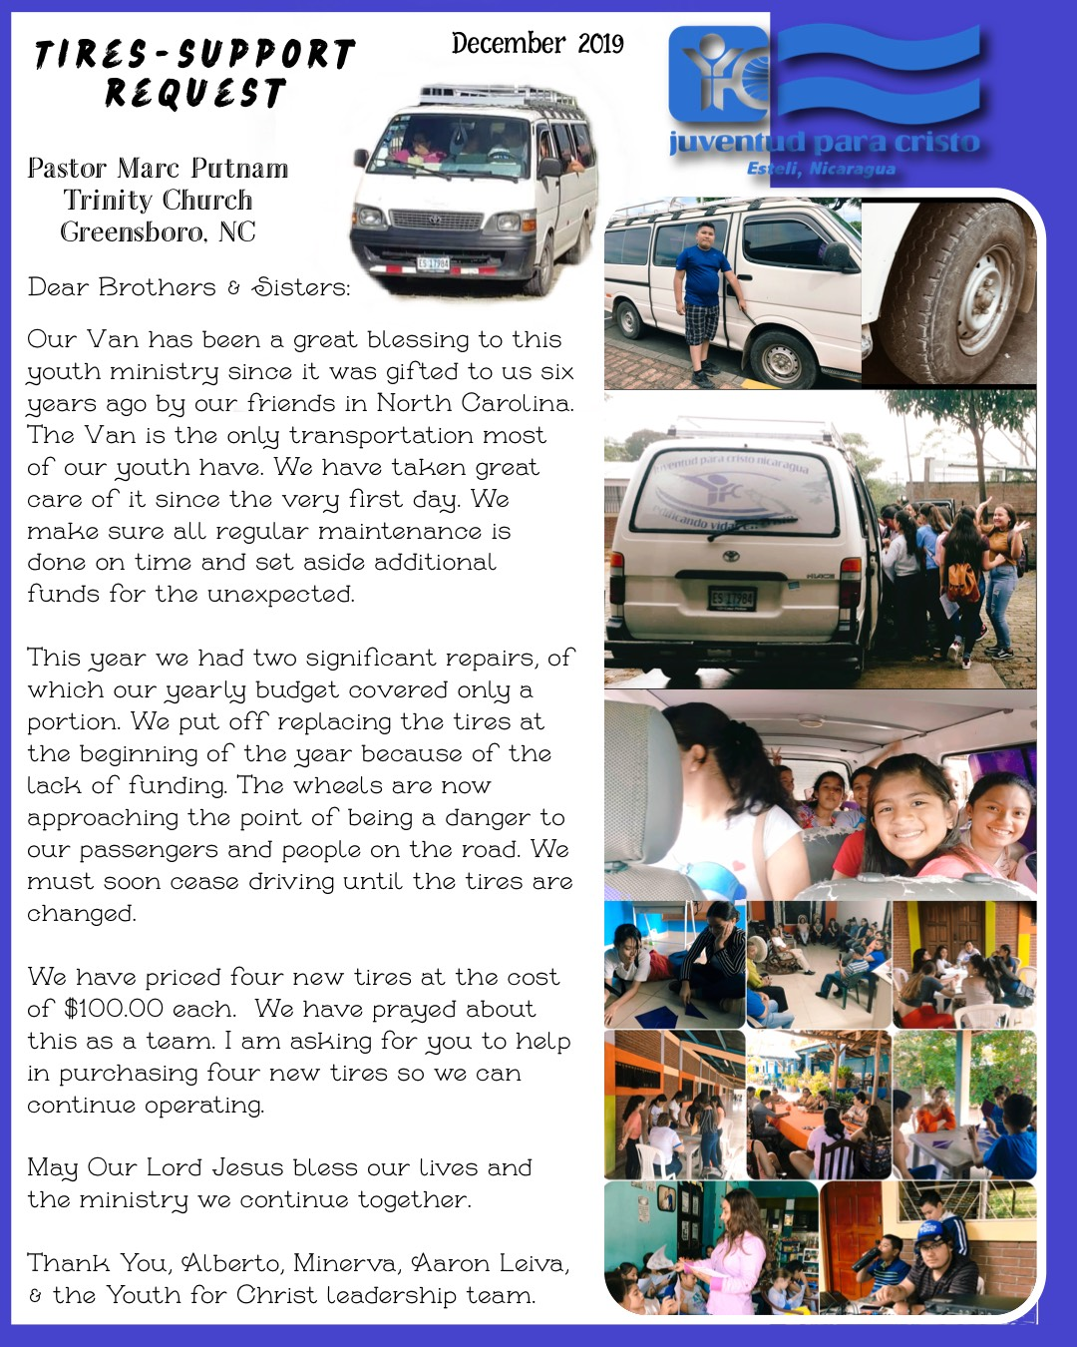

Youth for Christ Nicaragua works with at risk youth in an environment of extreme political and economic uncertainty. The message of Jesus Christ brings hope and the only possibility of peace in this place. Our Mission Team received this request for new tires from Alberto Leiva, our Youth for Christ partner in Nicaragua. Through your generous giving Alberto and YFC Nicaragua will be able to continue ministry with new tires on their van.

